**Class Activity: Firebase**

1. Create a new project with the following configuration,
   1. Empty Activity
   2. Language: Java
   3. Minimum API level: API 21: Android 5.0 (Lollipop)
2. Reuse the xml layout file and the Note class (Need to remove the Room database related annotations) created in Activity 10_room_database for this activity.
3. Follow the steps taught in the slides to create a new project in the Firebase console and connect your Android app to the Firebase project.
4. After creating the Firebase project, create a Realtime Database and set up the database with its location and security rules.

In this activity, you can set it in Singapore. 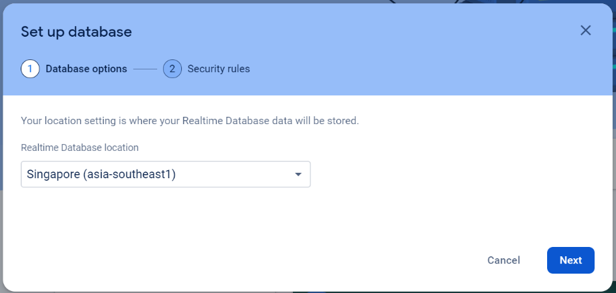

Choose the “Start in test mode” for security rules for this activity.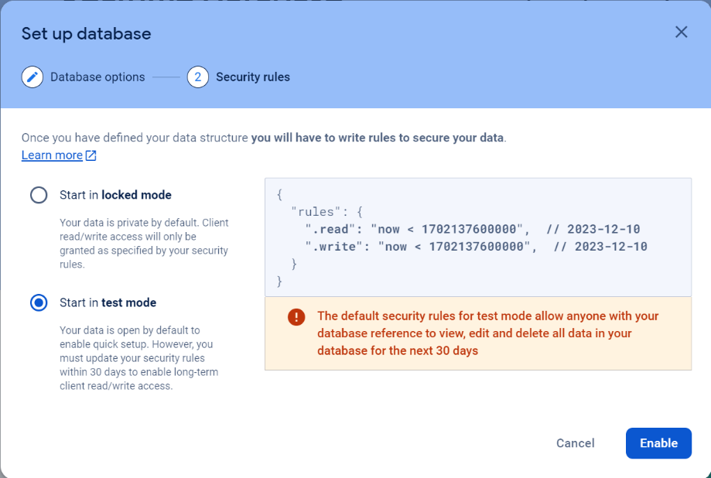

1. In the *Main Activity.java*, declare variables to link specific UI elements from the Android layout file. Retrieve an instance of your database using getInstance() and reference the location you want to write to.

Since we are using Singapore as our database location, you need to pass the database URL to getInstance(). For a us-central1 default database, you can call getInstance() without arguments.

1. To make your app data update in real-time, you should add a ValueEventListener to the reference you just created.
2. In the *MainActivity.java*, create setOnClickListener for the save and delete buttons. For the save button, it should store the title and content inputted by the user as a Note object into the database. For the delete button, it should delete the Note object from the database.

For the simplicity of this activity, set id = 1 when you insert or delete the Note object into Firebase. You can choose to use the id attribute as the primary key of the Note object in Firebase. When a new record with the same primary key is inserted into Firebase, it will replace the old record.

1. **Expected Output**

